How to Prune Tomatoes

When growing tomatoes, the ultimate goal is to help the plant yield as much ripe fruit as possible. If you're growing indeterminate or "vining" varieties, pruning your plants to remove unwanted shoots and leaves ensures that all the nutrients are going to the tomatoes. If you're growing a determinate variety, too much pruning is counterproductive. Indeterminate varieties grow like vines, and they must be trained upright on poles and pruned in order to grow correctly. Determinate varieties contain themselves before they grow into a bush, and they naturally direct their energy toward fruiting without needing as much intervention. Here are the common varieties of each:

Indeterminate: Big Boy, Beef Master, Paul Robeson, Brandywine, Black Prince, German Queen, most cherry tomato varieties and most heirloom varieties.

Determinate: Ace 55, Amelia, Better Bush, Biltmore, Heatmaster, Heinz Classic, Mountain Pride and Patio.

When To Start Pruning
Check the plant for signs of yellowing. One way to know when it is time to start pruning is to wait for the stems and leaves below the first set of flowers to turn yellow. When you notice this color change, you can start pruning.

Look for flowers. It is a good idea to start pruning your tomato plants early, as soon as there are flowers on the plants. At this point, the plants should be between 12 and 18 inches. Make sure the vine-like plants are tied to supports after flowering occurs. Otherwise, the vine will grow along the ground and won't produce healthy tomatoes.

Prune suckers all summer long to keep the plant healthy. They grow quickly, so you may need to prune once or twice a week.

Identifying Suckers
Look for the tiny new branches sprouting in the crotch of the plant where a branch meets the main stem. These are called "suckers" and they're what you want to remove. Suckers left to grow will eventually grow to the same size as the main stem, using up energy and nutrients from the rest of the plant, causing the plant to bear smaller, lower quality fruits. Strategically removing suckers will help your plant bear large fruit all season long.

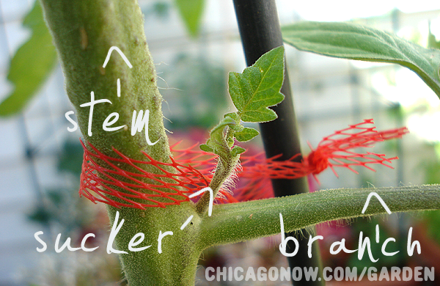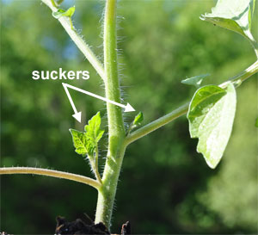

Remove all suckers and their leaves below the first flower cluster. Do this no matter what kind of tomato plant you have. This keeps the plant strong by helping it grow a sturdy central stem. This should ensure that the majority of the nutrients are sent to the fruits, instead of being wasted on the unwanted growing tips.

As for stems and leaves, not the suckers, growing below the first flower cluster: If your plant is in a humid environment (such as a greenhouse), remove everything below the first flower cluster to improve ventilation. Humidity can make it easier for sicknesses to flourish, and it also causes the wounds that are created while pruning to dry up more slowly making the plant longer vulnerable. By improving ventilation, you're helping to protect the plant.

Removal Techniques
To remove a sucker, grab a growing tip by the base between the thumb and forefinger (with clean hands) and bend it back and forth until it snaps cleanly. This should ideally be done when the shoot is young and supple. The small wound will heal quickly. This is called "simple pruning".

Leave the thicker shoots. Thicker suckers should not be snapped off, since this could damage the whole plant. If it's thicker than a pencil, use the "Missouri pruning" method and pinch out just the tip of the sucker, leaving one or two leaves behind for photosynthesis and to protect developing fruit from sun scald. The drawback is that suckers will develop from the stem that you leave behind, which will require additional pruning. This technique is better when you're dealing with large suckers; if the wound becomes diseased, it will be further away from the main stem. This method
also leaves a few inches on the sucker to reduce the shock to the plant.

Maximizing Fruit Production
Pinch off all but four or five fruit bearing trusses for indeterminate varieties. These are the branches that grow from the main stem above the first flower cluster. Four or five will produce large, healthy fruit, but any more than that and the fruit will be small and scant. Choose four or five sturdy trusses to keep, then pinch out any additional side shoots, leaving the plant's top shoot intact, known as the terminal shoot.

Remove yellow leaves. Yellow leaves are leaves that use up more sugar than they produce. As the plant begins to mature, the lower leaves will naturally begin to yellow and wilt. This is perfectly normal, so pull these from the plant when they appear. It will keep the plant fresh and help ward off disease.

Topping the Plant
To get the best out of the last growth of the season, it is necessary to "top" the plant. About a month before the first expected frost, or when the plant hits the roof of your greenhouse, remove the plant's terminal shoot. At this point in the season, the tomatoes currently growing will have a limited time to reach maturity, so all nutrients must be directed straight to the fruit.

Questions

When should I start pruning? Should my tomato plants be trimmed if they are brown and have dead leaves? I have beef steak and better boy plants. They are up to about 5 feet tall and have very few tomatoes on them. What should I do? What is the determining factor that makes my tomatoes determinate or indeterminate plants? How long do tomato plants live, and do they die off every year?

You can start pruning safely after the first set of flowers appears. Some growers like to prune the bottom set of limbs when transplanting tomatoes out to the field.

Yes, you should trim off any dead, diseased or broken limbs.

You can self-pollinate the tomato flowers with an electric toothbrush. Turn the brush on and hold it to the back of the flower it releases pollen. Every bloom I've done this to has turned into a tomato.

The vast majority of tomatoes for sale are indeterminate. Look for words like "patio" or "bush" that would suggest a compact, or determinate plant.

They live until the first frost, or until they get blight from rainy/moist weather. Unless you live in a tropical area or have a greenhouse, they will die every year.

How tall should I allow a tomato plant to grow? Should I remove the leaf stem below a sucker rather than the sucker itself? I have heard that it is a better way to do it. Can I pinch off early blossoms? Do my tomato plants need calcium if the bottoms of the tomatoes are brown?

Until you see tomatoes form on most of the branches. Then cut off the branches that still have only flowers (or no flowers) and the flowers that have not produced fruit.

No. The sucker will try to produce more fruit. The fruit should be made on the main stem.

You can, but why would you? Those blossoms will bear tomatoes, so I'd just let them grow.

Yes, either a calcium spray, which you can make from water and one of the calcium products intended to stop fruit rot, or a fertilizer with calcium in it applied just above the roots will solve the problem.

To avoid infecting your tomato plants, always prefer fingers over blades for removing shoots (the resulting wound can be easily infected). However, for older, tougher shoots, you may have to resort to using a blade; if so, sterilize your cutting implement thoroughly for each use.

If you smoke, wash your hands thoroughly with soap and water before handling tomato plants. Tobacco smokers can easily infect tomato plants with "Mosaic Virus."

Sterilized cutting equipment if using (clean hands preferred)

